Journal of Renewable Energies xx (20xx) xx – xx

Journal of Renewable Energies
Revue des Energies Renouvelables

journal home page: https://revue.cder.dz/index.php/rer

Research paper
Title of your paper (Times New Roman, bold, 16, left justified)
First Authorª, Second Author ^{b}, Third Author ^{a,b,}
(Times New Roman, bold, 12)
ª First affiliation, Address, City, Country (Times New Roman, Italic, 10)
^{b} Second affiliation, Address, City, Country (Times New Roman, Italic, 10)

ARTICLE INFO |  | ABSTRACT
Article history:  Received  Accepted |  | Every paper must be attended by an abstract concise and factual. A maximum of 200 words with no abbreviations or acronyms is recommended (see Authors Guide). Type your Abstract here (Times New Roman, 10, justified), Provide a maximum of 6 keyword and avoid general and plural terms and multiple concepts. These keywords will be used for indexing purposes
Keywords:
Keyword
Keyword
Keyword
Keyword
Keyword

1. INTRODUCTION
Manuscripts should be submitted online on the JRE website (https://revue.cder.dz). You must register to create an account if you do not have one. When submitting the article, you will be asked to add the email addresses of all of your co-authors and to add keywords. Journal of Renewable Energies considers only Full-Length Articles (4000-7000 words). The research papers must be original and high-quality. Manuscripts should be written in English, with a maximum of 20 pages. To avoid unnecessary errors, you are strongly advised to use the free Grammar Check tool. The manuscript organization should follow this order: Title, Authors, Affiliations, Abstract & Keywords, Main text, Acknowledgements, Appendix, Nomenclature, References.
The abstract should be concise and factual. A maximum of 200 words with no abbreviations or acronyms is recommended. Provide a maximum of 6 keyword and avoid general and plural terms and multiple concepts. These keywords will be used for indexing purposes.
A state-of-the-art should be presented in the introduction, with references cited in author-year format (see section References). The purpose of the study and the added value of the submitted paper should be clearly described.
Usually, the applied methodology, data, and tools are presented in section 2. If numerical investigations are performed, the applied approach should be validated.
The section Results should include representative results that are essential for discussion. Data should not be duplicated among figures, tables, and text. The text should be used to summarize what the reader will find in the tables, and figures, or mention the most important data points. The description of results should be followed by their interpretation and discussion. Results should also be compared with those from other studies.
In the Conclusion section, the most important results of the study should be summarized. Authors should indicate how the presented results extend the findings of previous studies. Authors are encouraged to add a Future Works subsection.
2. PAPER LAYOUT (Times New Roman, bold font, capital letters, 12)
The manuscript must be written on standard paper (A4 format). The full text is formatted in one column, with 1.15 line spacing, margins of 2.5 cm on each side, and justified on the right and the left. The typeface used for the text of the manuscript is Times New Roman, normal font, size 11. Upper and lower spacing of paragraphs should be 6 pt. Bulleted or numbered lists may be included and should follow the following format:
- First point
- Second point
- Third point
- ………..
You can use this document as a template.
2.1 Headers (Times New Roman, bold font, 12)
The article should be divided into sections, clearly defined and numbered. All titles are flush left.
2.1.1 Title of sections
Title of sections (Level one headings) are in Times New Roman, capital letters, bold font, size 12. Upper and lower line spacing of section titles should be 18 pt and 12 pt respectively.
2.1.2 Title of subsections
Titles of subsections (Level two headings) are in Times New Roman, bold font, size 12. Upper and lower line spacing of subsection titles should be 12 pt and 6 pt respectively.
2.1.3 Title of sub-subsections (Times New Roman, Italic font, 12)
Titles of sub-subsections (Level three headings) are in Times New Roman, italic font, size 12. Upper and lower line spacing of sub-subsection titles should be 12 pt and 3 pt respectively.
2.2 Equations and Symbols
The equations should be editable (not in the image format) and numbered. To build and insert equations, use Insert/Microsoft Equation. Equations can be inserted in the text otherwise they are centered and numbered with the numbers in parentheses flush right. A line spacing of 12 pt should be inserted above and below each equation (see Eq. (1)). The symbols in the equations should be defined before the equation appears, or immediately following. Refer to equations with “Eq. (1)” or “Eqs. (1) and (2)”. At the beginning of the sentences, “Equation (1)” or “Equations (1) and (2)” could be used. To insert symbols within the text, use Insert/Symbol/Font Symbol.
$$A∙x+B=\frac{log⁡(x)}{x}$$ | (1)
2.3 Figures and Tables
All figures should be numbered with Arabic numerals. Figures should be clear, explicit, and numbered in the text. Each illustration must have a legend placed below and written in Times New Roman, normal font, 11, with upper and lower line-spacing of 6 pt and 12 pt respectively (Fig. 1). Refer to the figures with “Fig. (1)” or “Figs. (1) and (2)”. At the beginning of the sentences, “Figure (1)” or “Figures (1) and (2)” could be used.
Tables should be numbered in the text and presented as editable text and not as images. The data presented in the tables do not duplicate the results given in the figures. All tables should have a caption centered and placed above the Table. The caption format of Tables is Times New Roman, normal font, 11, with upper and lower line spacing of 12 pt and 6 pt respectively. See Table 1 for Table Style.
2.4 Nomenclature, abbreviations, and acronyms
Abbreviations and acronyms should be defined the first time they are used in the main text. A nomenclature section, not numbered, could be added before the References section. Latin variables then Greek symbols should be cited in alphabetic order.
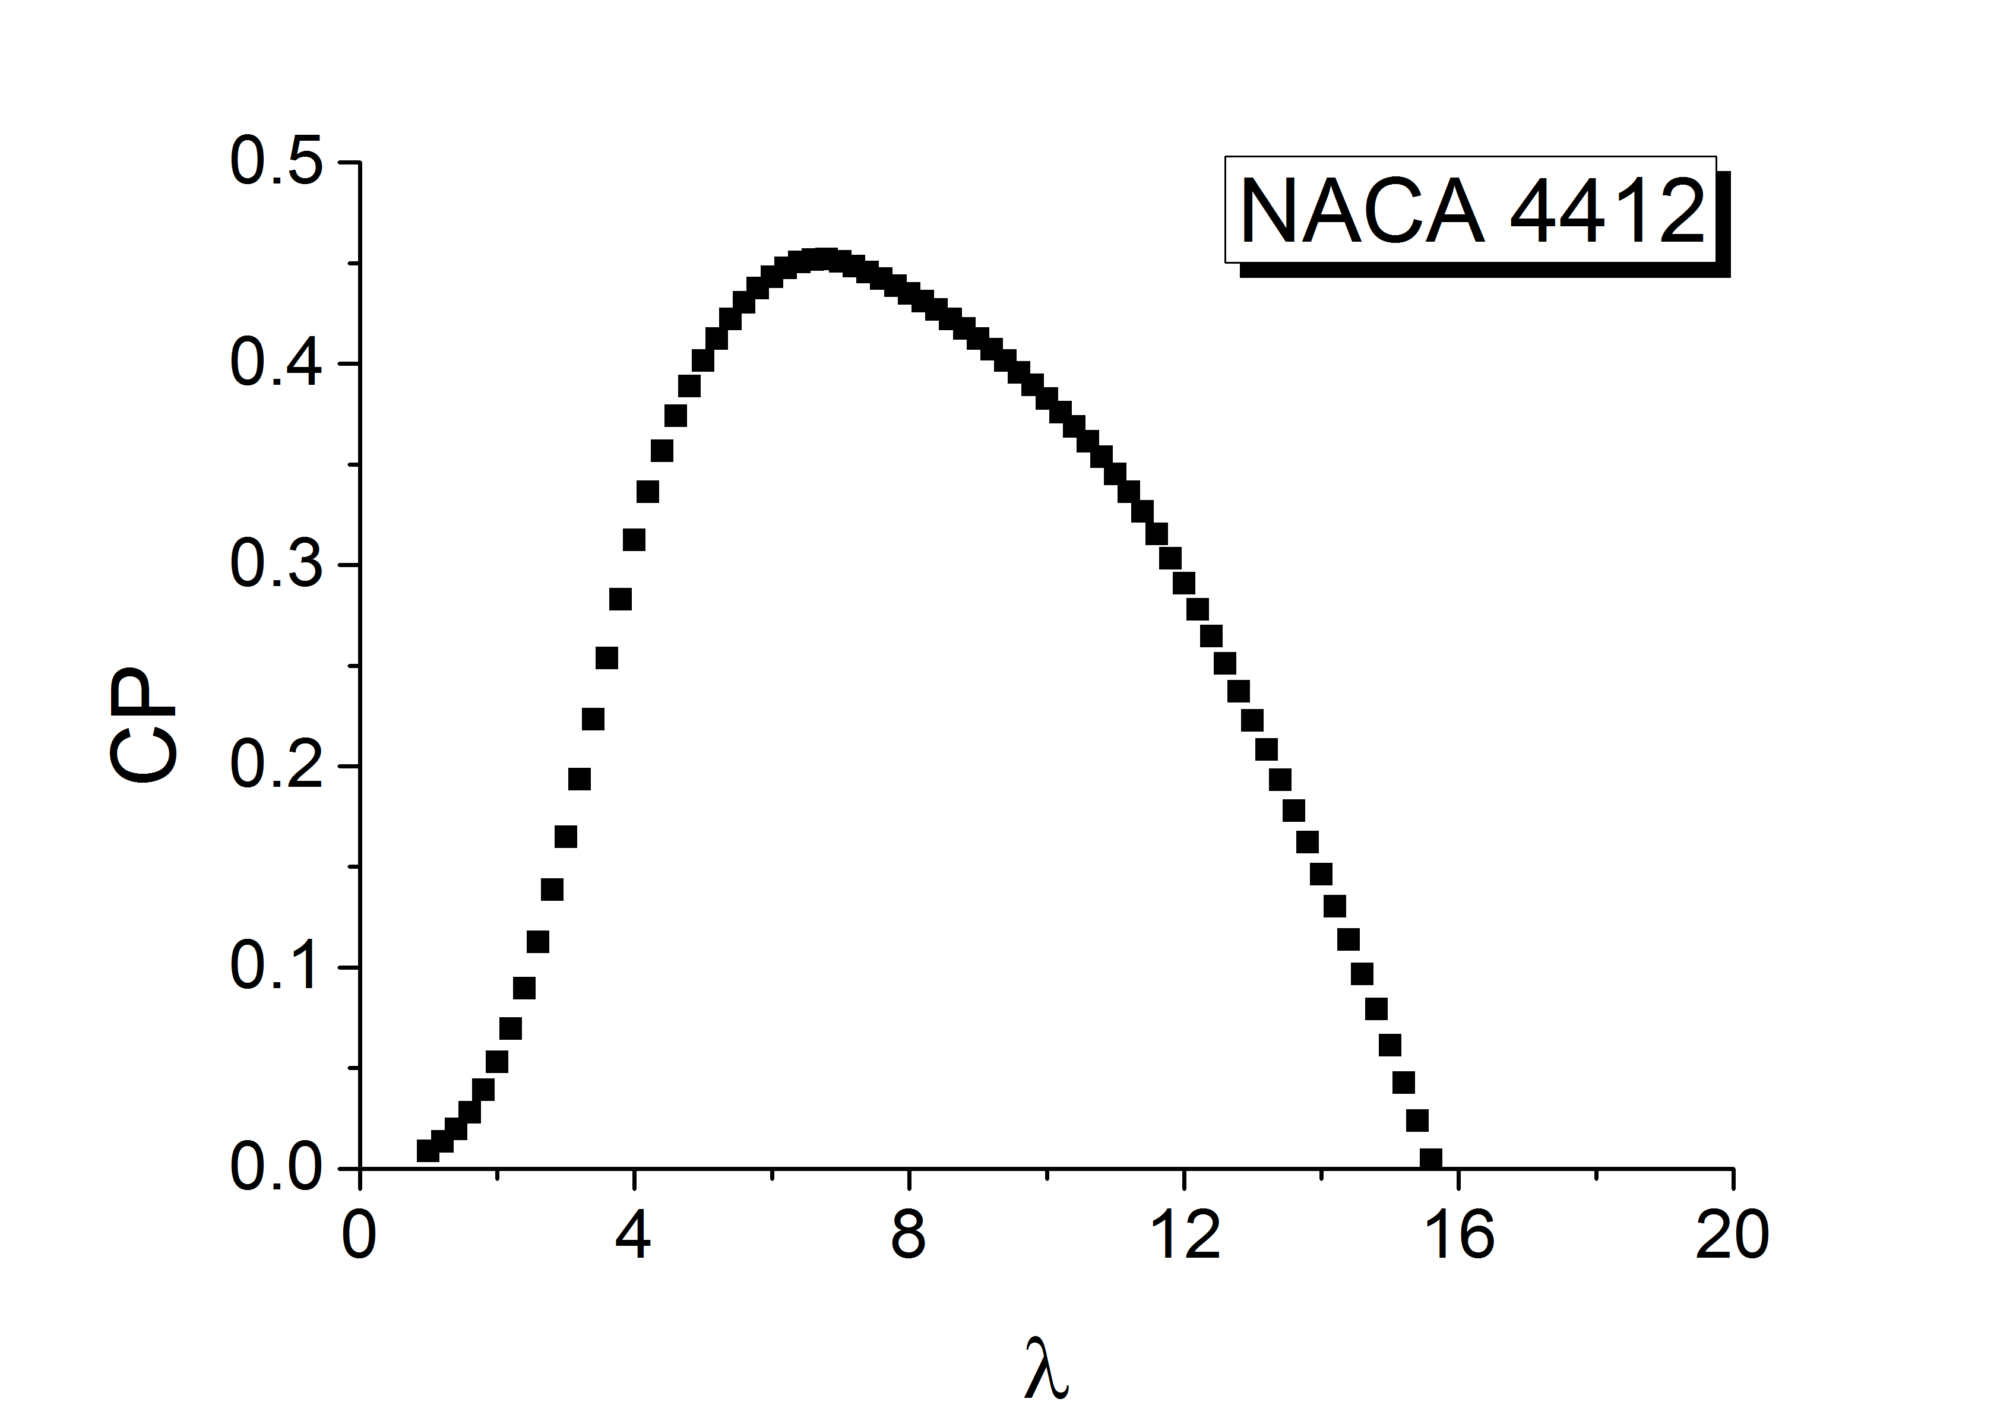
Fig 1. An example of a figure
Table 1. An example of a Table
An example of a column heading | Column A (t) | Column B (t)
And an entry | 1 | 2
And another entry | 3 | 4
And another entry | 5 | 6
Insert the table footer(s) here if any (Times New Roman, 10).
3. OTHER GUIDELINES
Authors are invited to refer back to the journal's policies and publication ethics statements:
- The information contained in manuscripts submitted for publication should present the results of the research carried out by the authors.
- Authors should guarantee that they have written a completely original study, and if they have used work or comments from other people, these should be properly cited. Authors should cite publications that influenced the study in question.
- Submission of the same manuscript in parallel to another journal is unacceptable.
- Only those who made a significant contribution to the study can be listed as authors or co-authors.
- The main author must ensure that all the co-authors have seen and approved the final version of the manuscript and that they have given their consent to the submission of the manuscript.
- All authors should indicate any conflicts of interest that may affect their interpretation of the manuscript.
- If the author discovers a material error or an inaccuracy in his/her publication, he/she should promptly inform the editor and consider, in agreement with the editor, the withdrawal of the article or the publication of the error information.
- If the manuscript has been reviewed or is under review, authors cannot withdraw it and must sign the transfer of Copyright to JRE.
ACKNOWLEDGEMENTS
The acknowledgments section is not numbered. The text is in Times New Roman, normal font, 11.
APPENDIX
Authors including an appendix section should do so before the Nomenclature section. Multiple appendices should all have headings in the style used above. They will automatically be ordered A, B, C, etc.
NOMENCLATURE
The nomenclature section is not numbered. Variables are listed alphabetically in Times New Roman, normal font, size 11.
A | Area [m2] | COP | Coefficient of performance
Cp | Specific heat [kJ/kg·K]
T | Temperature [°C] | η_{c} | Solar collector Efficiency
V | Specific volume [m³/kg] | η | Overall efficiency
REFERENCES
The references section is not numbered. References are listed alphabetically in Times New Roman, normal font, 11. Authors should follow APA Style for citations of the references in the text and the references section. Authors are encouraged to provide the DOI of the reference entries.
Reference to a journal publication:
Chae KJ, Kim IS, Ren X, Cheon KH. (2015) Reliable energy recovery in an existing municipal wastewater treatment plant with a flow-variable micro-hydropower system. Energy Convers Manag 2015;101:681–8. doi:10.1016/j.enconman.2015.06.016.

Reference to a book:
Strunk Jr W, White G. (2018). The elements of style. 3rd ed. New York: Longman.

Reference to a chapter in an edited book:
Wang H., Adams LB. J. (2009). Renewable Energies. In: Jones BS, Smith RZ, editors. Names of editors, New York: E-Publishing Inc, p. 165–234.

Reference to a website:
Energy situation in Algeria. General reports for Algeria, http://www.energyreports.org/statistics/; 2003 [accessed 15 March 2020].

Corresponding author, E-mail address: s.jreen@cder.dz Tel : + 213 541765240

